The Poplet Kit Handbook © Copyright 2001 Handwave Inc., All Rights Reserved

Overview
The Poplet Kit is a set of work-saving enhancements to Palm OS applications. It provides shortcuts for built-in applications and automates information flow between applications. It reduces the number of steps you must do in obtaining web-based and handheld-based information. The Poplet Kit is a tap saver.

Some examples of Poplet Kit enhancements are:
- Get maps, driving directions and other web-based location services directly from address book entries.
- Search web and handheld databases for text appearing in e-mail messages, Adobe Acrobat documents, Microsoft Word files, doc files and memos. Simply highlight the search text within a reader application, popup a menu and choose the search target. Google, Encyclopedia Britannica, Merriam-Webster dictionary and Noah dictionaries are supported.
- Launch any application or web clipping while in any application.

The Poplet Kit makes available a global menu of functions which perform information access shortcuts for all Palm OS applications. There are also application-specific local menu functions which enhance several built-in applications. Poplet Kit menus are launched with the Poplet button on the Palm OS command bar (the hack-free approach) or with the Find silk screen button (the hack-based approach).

Poplet Kit functionality is delivered in the form of "Poplet modules". A Poplet module is a Palm OS database containing code that is easily shared with other devices via beaming or syncing. The Poplet menu consists of the list of available Poplet modules. Selecting a menu entry launches the associated Poplet module.

WordSmith With Highlighted Text | ➔ | 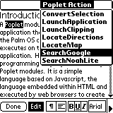  The Poplet Menu | ➔ | 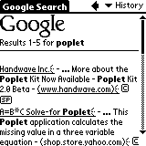  Results of Google Search

Example of Poplet Kit Orchestrating a Web-Based Google Search From WordSmith

The Poplet Kit also includes tools for programming new Poplet Modules in Handscript, a Javascript-based language. This enables the creation of personal application enhancements. It also facilitates creation of customized corporate applications that access information through the web or local databases.

The Poplet Module User Interface
Launching a Poplet Module - The Poplet Menu

The Poplet menu, shown below, can be popped up while running any application. First bring up the Palm OS command bar (shown to the right) using the graffiti command stroke, an upward diagonal swipe starting at the lower left of the graffiti area.  There is a Poplet button (the popping cork icon) which the Poplet Kit has added to the command bar. Tap the Poplet button and the Poplet menu appears. | 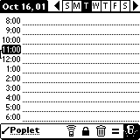  Command Bar "Poplet" Button

Select an entry in the menu to launch the associated Poplet module. Tap outside the menu to dismiss it.

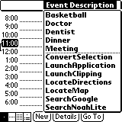  Poplet Menu Containing  Local Functions | If the menu contains a dotted line separator, the entries above the dotted line are application-specific local functions. In the Datebook example to the left, the local functions simply insert the text associated with their menu entry at the selected time.  Entries below the dotted line, or if no dotted line, all entries, are always present in the Poplet menu. They are global functions which are available in all applications.

The Poplet menu can be configured (see "Configuring the Poplet Menu" below) to contain only those modules (representing global functions) that you want to appear in the menu.

The Poplet menu also can be popped up with the Find silkscreen button, if the PopletFindButtonHack is installed. This approach saves one swipe operation compared to using the command bar, but it requires the installation of a hack manager such as HackMaster or X-Master. When the hack is installed, the Find operation is still available by tapping the Find button twice in succession. On the first tap the menu appears. On the second tap, the menu is dismissed and the Find dialog appears.

Every Field is a Calculator - The Equals Button

The Poplet Kit enables text fields in all Palm OS applications to evaluate numeric expressions. In other words, every field becomes a calculator! After installing the Poplet Kit, launch any application that contains a text field (for example, Date Book). Enter the expression 1+2*3 into the text field and highlight that text. Popup the command bar by drawing the graffiti command stroke. You will see an equal sign button (“=”) which the Poplet Kit has added to the command bar. Tap that button. | 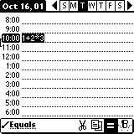  Command Bar “Equals” Button

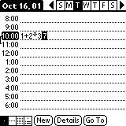  Calculating in the Date Book | The result of evaluating the expression is inserted into the field, giving you a permanent record of the computation in the context of its associated data. You don’t have to launch a calculator, just compute where you are.  Other examples of where this can be useful are memos, to-dos, address book entries, notes attached to addresses and email messages.

Poplet Kit Poplet Modules
The Poplet Kit includes the following Poplet modules:

Web Access Poplet Modules
The web access Poplet modules require an internet connection to access web sites and the Clipper application installed on the Palm OS device. In general, these modules produce the same results as freely available web clipping applications, but they require much less work than launching the web clipping and entering data into the clipping form.

Module Name  GotoURL | Module Description  Launch Clipper on the URL identified by the current text selection. If there is no selection, popup a dialog for entry of the URL. It the URL string supplied does not include a ":" character, prefix the URL string with the string "http://".
LaunchClipping | A menu of all web clipping (PQA) databases on the device is popped up. If an entry is chosen, launch Clipper to display the chosen clipping.
LocateATMs | An AddressBook dialog pops up. Select an address entry and Clipper is launched to display list of ATMs in the vicinity of the address. (Uses the Visa ATM locator web site.)
LocateDirections | An AddressBook dialog pops up. Select start and end address entries, and get MapQuest driving directions displayed by Clipper. Note, the Clipper local menu entry CopyToMemo can be used to save the driving directions in a memo.
LocateMap | An AddressBook dialog pops up. Select an address entry and Clipper is launched to display a MapQuest map for the address.
LocateMovies | An AddressBook dialog pops up. Select an address entry and Clipper is launched to display movies and theatres in the vicinity of the address, using the MovieFone web site.
LocateRestaurants | An AddressBook dialog pops up. Select an address entry and Clipper is launched to display restaurants in the vicinity of the address, using the Vicinity Brand Finder web site.
LocateStarbucks | An AddressBook dialog pops up. Select an address entry and Clipper is launched to display a list of Strarbucks coffee shops in the vicinity of the address.
SearchBritannica | Highlight text in a text field in any application, in Acrobat Reader, WordSmith or WordToGo. Popup the Poplet menu and tap SearchBritannica. The Encyclopedia Britannica web site is searched for the selected text and Clipper is launched to display the results. Tap the Clipper Back arrow to exit Clipper and return to the reader application.
SearchGoogle | Highlight text in a text field in any application, in Acrobat Reader, WordSmith or WordToGo. Popup the Poplet menu and tap SearchGoogle. The Google web site is searched for the web site references to the selected text and Clipper is launched to display the results. Tap the Clipper Back arrow to exit Clipper and return to the reader application.
SearchWebster | Highlight a word in a text field in any application, in Acrobat Reader, WordSmith or WordToGo. Popup the Poplet menu and tap SearchWebster. The Merriam-Webster dictionary web site is searched for the selected word and Clipper is launched to display the definition. Tap the Clipper Back arrow to exit Clipper and return to the reader application.

Device Access Poplet Modules
The following Poplet modules are shortcuts in accessing Palm OS device resident data.

Module Name  AverageSelection | Module Description  Highlight one or more space-separated numbers in a text field in any application, or in WordSmith or WordToGo. Popup the poplet menu and tap AverageSelection and the average of the numbers is inserted after the list.
BeamSelection | Highlight text in a text field in any application, in Acrobat Reader, WordSmith or WordToGo. Popup the Poplet menu and tap BeamSelection. The highlighted text is beamed to another device as a memo.
BracketSelection | Highlight text in a text field in any application, or in WordSmith or WordToGo. Popup the poplet menu and tap BracketSelection and a menu of bracket pairs is popped up (quotes, parentheses, braces, etc.). If a menu entry is chosen, the highlighted text is enclosed in the chosen bracket pair.
ConvertSelection | Highlight a number in a text field in any application, or in WordSmith or WordToGo. Popup the poplet menu and tap ConvertSelection and a menu of conversion types is popped up (distance, area, liquid, weight and currency). If a conversion type is chosen, a menu of units to convert from is popped up, followed by a menu of units to convert to. The results of conversion are inserted after the highlighted number.
HexReplaceSelection | Highlight text in a text field in any application, or in WordSmith or WordToGo. Popup the poplet menu and tap HexReplaceSelection and the highlighted text is replaced with the hexadecimal conversion of each of its characters.
HexShowSelection | Highlight text in a text field in any application, or in WordSmith or WordToGo. Popup the poplet menu and tap HexShowSelection and a dialog box is popped up showing side-by-side text and hexadecimal conversion of the text.
LaunchApplication | A menu of all applications on the device is popped up. If an entry is chosen, the application is launched.
ScrambleSelection | Highlight text in a text field in any application, or in WordSmith or WordToGo. Popup the poplet menu and tap ScrambleSelection. A prompter will pop up requesting you to enter a scramble key. Then a menu will allow you to choose between replacing the highlighted text or displaying the scrambled text in a dialog box. Two scrambles in succession with the same key return the selection to the original text.
SearchNoahLite | Highlight a word in a text field in any application, in Acrobat Reader, WordSmith or WordToGo. Popup the Poplet menu and tap SearchNoahLite. The Noah Lite application is launched to display the word definition. To return to the reader application, pop up the Poplet menu and tap the Noah local menu entry Back.
SearchNoahPro | Highlight a word in a text field in any application, in Acrobat Reader, WordSmith or WordToGo. Popup the Poplet menu and tap SearchNoahPro. The Noah Pro application is launched to display the word definition. To return to the reader application, pop up the Poplet menu and tap the Noah local menu entry Back.
SumSelection | Highlight one or more space-separated numbers in a text field in any application, or in WordSmith or WordToGo. Popup the poplet menu and tap SumSelection and the sum of the numbers is inserted after the list. This is a simple way to sum checkbook entries.

Configuring the Poplet Menu

Your Program Inventory - The Poplet Module List Form

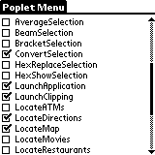  Poplet Module List Form | The Poplet Module List form shows all Poplet module databases installed on the device. To configure the Poplet menu, check the checkbox of those Poplet modules you want included in the menu. The menu shown above was configured using the list on the left.  Every Poplet module includes usage documentation within its database. Tap the text of a Poplet module name (e.g., Brackets) to see the Poplet documentation pictured below.

All Modules Have a Purpose - The Module Description Dialog

The Module Description dialog is shown on the right. It presents the Poplet module usage documentation. The Poplet module name is shown in the form title. To beam the Poplet database to another device, tap the Beam button . | 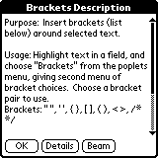  Module Description Dialog

Changing Module Attributes - The Module Details Dialog

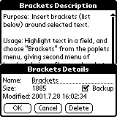  Module Details Dialog | Tap the Details button in the Poplet Module Description form to get the Module Details dialog. This lets you change the name of a module, change the backup attribute and delete the Poplet module from the device.  Check the Backup checkbox to cause the Poplet database to be backed up upon a hotsync operation. Tap the Delete button to delete the Poplet module. You will be asked to confirm deletion.

Ami Modules
Ami modules are special Poplet modules that are associated with Palm OS applications. Ami module names have a unique form: Ami_XXXX. The first four characters are "Ami_" and the next four characters XXXX match the creator ID of an associated Palm OS application. For example, the Datebook Ami module has name "Ami_date", because the creator ID of the datebook is "date".

There are two possible roles of an Ami module:
- To add local menu entries to the Poplet menu for the associated Palm OS application. The Datebook Ami module performs this role.
- To support copying of the text selection for those applications that do not use standard Palm OS text fields for displaying and selecting text. The WordSmith and WordToGo Ami modules perform this role.

The following Ami modules are provided:

Module Name  Ami_calc | Module Description  Adds local menu entries to the Poplet menu for the built-in calculator. Adds persistent memory to the calculator by allowing calculator value to be saved in and restored from named variables.
Ami_clpr | Adds two local menu entries to the Poplet menu for Clipper. "Copy Page Text To Dialog" copies the text in the current clipping to a dialog box. This allows the text to be selected in order to perform an operation on selected text, such as search Google. "Copy Page Text To Memo" copies the text in the current clipping to a memo. This is useful for preserving a clipping, such as saving driving directions.
Ami_date | Adds local menu entries to the Poplet menu for the built-in Datebook. When these entries are chosen, their text from the menu is inserted into the datebook at the selected time. This menu can be customized by editing function getInsertMenu in module Ami_date.
Ami_DTGR | Supports copying selected text in WordToGo. This enables evaluating expressions with the Equals button within WordToGo and enabling Poplet modules launched via the Poplet Menu to access the WordToGo text selection.
Ami_HsPr | Adds local menu entries to the Poplet menu for the Handspring built-in calculator. Adds persistent memory to the calculator by allowing calculator value to be saved in and restored from named variables.

Ami_KJK0 | Adds one local menu entry to the Poplet menu for Noah Lite. The Back menu entry exits Noah Lite and returns to the application which was running when Noah Lite was launched.

Ami_memo | Includes support in the memo application for beaming the selection, from other applications, as a memo.
Ami_NoAH | Adds one local menu entry to the Poplet menu for Noah Pro. The Back menu entry exits Noah Pro and returns to the application which was running when Noah Lite was launched.
Ami_WrdS | Supports copying selected text in WordSmith. This enables evaluating expressions with the Equals button within WordSmith and enabling Poplet modules launched via the Poplet Menu to access the WordSmith text selection.

Poplet Kit Developer Features

User Features Versus Developer Features

The Poplet Kit separates into these two different kinds of activity:
- End-user configuration of the Poplet menu from available Poplet modules.
- Developer creation of new and modification of existing Poplet modules.
You explicitly switch between these worlds with the menus shown below:

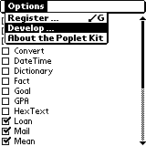  Poplet List Form | To development ➔  ⬅ To user configure | 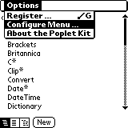  Poplet Module Hierarchy Form

The Poplet Module Hierarchy Form

The Poplet Module Hierarchy form (first pushbutton) uses indentation to show the module inheritance hierarchy. In the picture on the right, all modules below Object inherit from Object. An asterisk after the module name indicates a “base “module”. Base modules are always present (they are included as resources in the Poplet Kit prc). As such, they cannot be changed.  Tap a module name to see the function list for the module. | 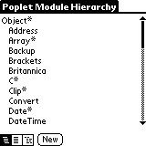  Poplet Module Hierarchy Form

Creating a New Module

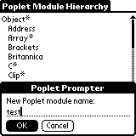  Creating Poplet Module Test | Create a new Poplet module by tapping the New button in the Poplet Module List form. You will be prompted to enter the new Poplet module name. Enter a name not used by any other program. Poplet module names always begin with a capital letter, so the Poplet Kit capitalizes the name in case you do not.  If you tap the OK button, the Poplet module database is created with default documentation and no functions. Then the Function List form described below is entered.

A Module is a Group of Functions – The Function List Form

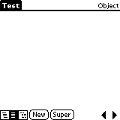  Empty Module Function List Form | After creating a new Poplet module, the Poplet Module Function List form (second pushbutton from left selected) is displayed with an empty function list. The module name is shown in the form title. Tap the New button to create a new function. This opens the Function Editor form as shown on the following page.  Browse to the function list of the previous/next Poplet module using the arrow buttons on the lower right. Again, after the last program, you will cycle back to the first.

Tapping the second pushbutton in any form brings up the Poplet Module Function List form for the most recently selected module. The example to the right shows the function list for the Brackets Poplet module. Each list entry shows the function name and arguments. Tapping an entry opens a Function Editor form on the source code for the associated function. | 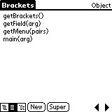  Module Function List Form

Copy Functions From Module to Module

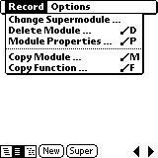  Including Functions | Often a new Poplet module needs to use functions which are contained in another program . This is especially true of functions which wrap OS calls, which may be needed in many programs. You can either call the functions in the other program or copy them into the current program. The “Copy Module …” and “Copy Function …” operations copy function source code for the selected functions to the current Poplet module. The advantage of copying is that the resulting program is self-contained; it doesn’t need other programs to run.

A Function is Handscript Code – The Function Editor Form

The Function Editor form is used to create and browse the source code for a single function at a time. Create a new function by tapping the New button in the Function List form. This opens the Function Editor form with the template of the source code for a new function completed for you, as shown in the example to the right.  See Handscript: The Poplet Programming Language for information on how to program in Handscript. | 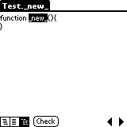  New Function Template

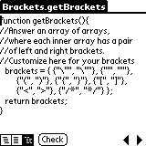  Function Editor Form | There are three ways to enter the Function Editor form: (1) tap the New button in the Function List form, (2) tap a function entry in the Function List form to select a function to view and (3) tap the third pushbutton while in any form. The latter brings up the Function Editor form displaying the source code for the most recently selected function.

The Function Editor form uses a text field for function source code. There is a standard edit menu for performing cut, copy, paste and undo operations.  Function source code may be browsed in alphabetical order of function name by repeatedly tapping the arrow keys at the bottom right of the form. After the source for the last function in a poplet is shown, the source for the first function in the next poplet is displayed. | 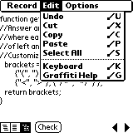  The Standard Edit Menu

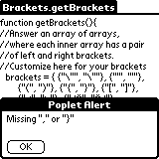  A Syntax Error Message | Tap the Check button to perform a syntax check, after modifying the source code for a function. If there are no errors, the message OK! flashes briefly to the right of the Check button. If there is an error, a dialog box describing the error pops up. After the dialog is dismissed, the insertion point is placed at the position of the error in the source code.

The Restore Function menu item discards changes made to the function source code and reverts back to the last saved version. The Delete Function menu item asks for confirmation, then, if confirmed, deletes the function from the poplet. The New Function menu item enters the code for an empty new function. | 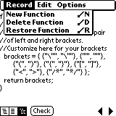  Function Operations

